# *A PROJECT REPORT ON*

SIMULATION OF NUMERICAL RELAY PROTECTION AND DIFFERENTIAL RELAY PROTECTION ON VIRTUAL POWER LAB

IN THE PARTIAL FULFILMENT OF THE REQUIRMENT FOR THE DEGREE OF

BACHELOR OF TECHNOLOGY

In

ELECTRICAL ENGINEERING

By

RAJIT KUMAR

SAKSHAM PATHAK

SUNIL CHHALOTRA

YOGESH KUMAR

Under the guidance of

Prof. D.K. CHATURVEDI



TABLE OF CONTENT

* Certificate 3
* Abstract 4
* Declaration 5
* Acknowledgement 6
* Introduction of Project 7
* Introduction to virtual lab 7
* Objective of project 7
* Differential protection of transformer 8
* Numerical Protection of Induction Motor 12
* Some Basics about html used for simulation 15
* Images used for simulation of experiment 16
* Differential Protection of Transformer 16
* Numerical relay protection for induction motor 21
* Reference 25

## CERTIFICATE

This is to certify that Project Report entitled “SIMULATION OF NUMERICAL RELAY PROTECTION AND DIFFERENTIAL PROTECTION ON VIRTUAL POWER LAB” that is submitted by RAJIT KUMAR, SAKSHAM PATHAK, SUNIL CHHALOTRA, YOGESH KUMAR in partial fulfillment of the requirement for the award of the degree B.Tech in Department of ELECTRICAL ENGINEERING of Dayalbagh Educational Institute, is a record of the student own work carried out by him under my own supervision. The matter embodies in thesis is original and has not been submitted for the award of any other degree.

Date: Project guide:

(Prof. D.K. CHATURVEDI)

## ABSTRACT

Physical distances and the lack of resources make us unable to perform experiments, especially when they involve sophisticated instruments. Also, good teachers are always a scarce resource.

Electrical machines and power system are the back bone of electrical engineering and play a vital role in industry. It is therefore essential that students of Electrical Engineering should have a proper background in these areas.

It is observed that the students do not take much interest in the laboratory. Hence, the necessity is felt to explain the concepts of electrical machines with suitable programs besides the theory and practice. This will provide better understanding of the subject.

**Goal of the virtual power lab**

To develop virtual machines and power laboratory to facilitate the students to work for their own convenience and easily understand the practical concepts. It helps in generating the interest in students' community to get better insight about the subjects related to machines and power systems.

Lab work is very important to bridge the gap between the theoretical knowledge and practical work. The motto of the laboratory work is to learn here and earn outside.

Students always have fear while working experimentally in the laboratories. Especially in electrical engineering labs like machines lab where the voltage level is generally 230 V or 415 V at 50 Hz, which may cause a serious shock or sometimes cause death also. Hence, there is a need to follow certain precautions to work safely in the lab. While working in lab, one must properly be isolated from ground (i.e. wear proper shoes), so that there is no chance of flowing the leakage current through the bod

DECLARATION

We hereby declare that this submission is own work and that, to the best of our knowledge and belief, it contains no material previously published or written by another person nor material which to a substantial extend has been accepted for the award of the award of any other degree or diploma of the university or other institute of the higher leaning except where due acknowledgement has been made in the text.

**Name: Rajit Kumar(134100)**

**Saksham Pathak(134105)**

**Sunil Chhalotra(134117)**

**Yogesh Kumar(134120)**

**Date:**

## ACKNOWLEDGEMENT

First and foremost, We deeply indebted to our mentor Prof. D. K. Chaturvedi, whose inspiration has been unfailingly available to us at all stages of our training. This has fueled our enthusiasm even further and encouraged us to boldly step into what was a totally dark and unexplored expanse before us.

In course of present work it has been our privilege to receive help and assistance of our friends. We take great pleasure in acknowledge our debt to them.

We wish to thank our parents for their undivided support and interest who inspired us and encouraged us to go our own way, without whom we would be unable to complete our project. At last but not the least we want to thank our friends who appreciated us for our work and motivated us and finally to God who made all the things possible.

**Name: Rajit Kumar(134100)**

**Saksham Pathak(134105)**

**Sunil Chhalotra(134117)**

**Yogesh Kumar(134120)**

**Date:**

1. **Introduction of Project**

**INTRODUCTION TO VIRTUAL LAB**

Virtual Labs is a project initiated by the [Ministry of Human Resource Development](https://en.wikipedia.org/wiki/Ministry_of_Human_Resource_Development), [Government of India](https://en.wikipedia.org/wiki/Government_of_India), under the National Mission on Education through Information and Communication Technology. The project aims to provide remote-access to Laboratories in various disciplines of science and engineering for students at all levels from under-graduate to research.

It also intends to develop a complete Learning Management System where the students can avail the various tools for learning, including additional web-resources, video-lectures, animated demonstrations and self-evaluation. There is also a component wherein costly equipment and resources are shared, which is otherwise available to only a limited number of users due to constraints on time and [geographical distances](https://en.wikipedia.org/wiki/Geographical_distance).

* 1. **Objective of Project**

The objective of project is to simulate two experiments of the Power System Lab . One is the Differential Protection of Transformer and the other is the Numerical Relay Protection.

The full details of the two experiments are mentioned as follows:-

***Differential Protection***

***OBJECTIVE*:** To study the differential Protection of Power/Distribution transformer.

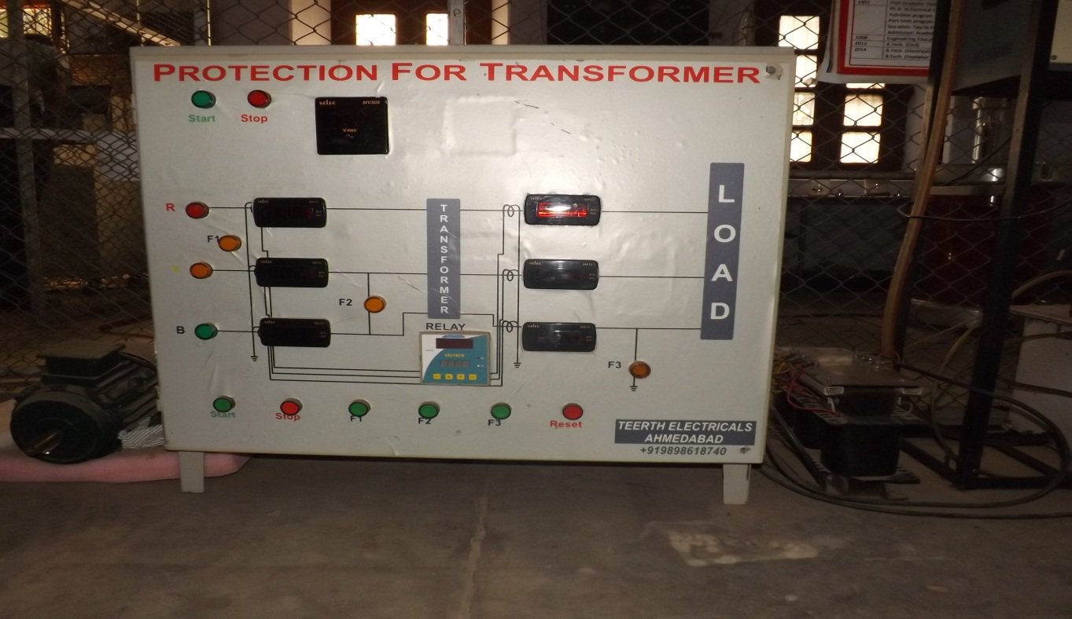

***EQUIPMENT REQUIRED*:**

* + - Main Transformer
    - Current Transformers
    - Differential Relay

***LINE DIAGRAM:***

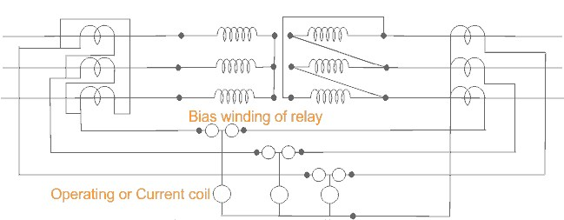

Schematic diagram for differential protection of three phase transformer.

***THEORY*:**

A transformer is a static device totally enclosed and generally oil-immersed. Thus, chances of fault occurrence on them are rare. However, consequences even so, could be very serious unless the transformer is quickly disconnected from the system.

Power transformers are classified as one of the most valuable equipment in a power system, hence their protection is of very high importance. The transformer differential protection provides fast tripping in case of a fault - before severe damage spreads out. Such faults are:

* short circuits between turns, windings and cables inside the transformer housing
* earth faults inside the housing
* Short circuits and earth faults outside the housing but within the protected zone (e.g. at bushings or supply lines).

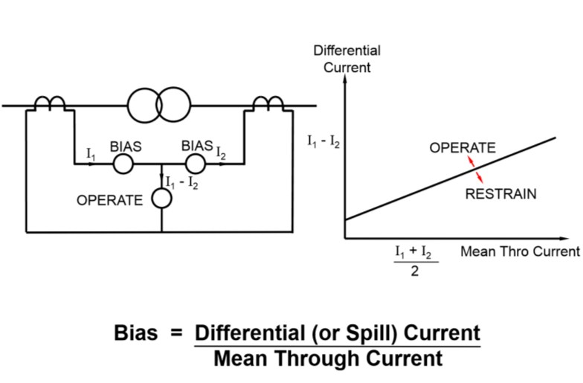

(Diagram of Biased Differential Protection)

A differential relay is one that operates when the phase difference between the two or more similar electrical quantities exceeds a pre-determined value.

***WORKING AND OBSERVATION*:**

The differential relay is one that compares the current entering a section of the system with that leaving the section. Under normal operating conditions or external fault (fault falling out-of-zone) the two currents are equal but as soon as some internal fault occurred this condition of equality of the two current ceased to be true. Then, the difference b/w the incoming and outgoing current is arranged to flow through the operating coil of the relays. If this differential current is equal to or greater than the pickup valve the relay will operate and open the circuit breaker to isolate the fault-section. The different problems in differential protection of transformer are:

* Current Mismatch Caused by the Transformation Ratio
* Due to possible mismatch of ratios among different current transformers.
* DeltaWye Transformation of Currents
* Zero Sequence Elimination
* Phase differences between primary and secondary side, caused by transformer vector groups, have to be duly considered.
* Switching operations in the grid have to be recognized as such.
* Inrush currents of the transformer must not result in maloperation.

Connection of interposing C.T.s is dependent on the vector group of the power transformer. For instance, for transformers with star (Y) windings the interposing C.T.s are connected in delta (Δ) to reject residual currents (i.e. currents flowing to the transformer due to an earth fault outside the protected zone and which would produce a differential current Id) and to prevent mal-operation of the differential protection.

**Transformer Inrush**

When a transformer is first energized, a transient in- rush current flows. This inrush current occurs only in the energized winding and has no equivalent on the other side of the transformer. The full amount of inrush current appears as differential current and would cause the differential relay to trip if there is no stabilization against the inrush phenomenon.

Typically the inrush current contains three components that distinguish it from other fault currents:

1. The DC-component: The DC-component is present at least in one phase of the inrush current, depending on the instant of energizing.
2. The second harmonic: The second harmonic is present in all inrush currents due to uni-directional flux in the transformer core.
3. The fifth harmonic: The fifth harmonic is present when the transformer is subjected to a temporary overvoltage.

***Numerical Relay Protection***

***OBJECTIVE:*** To study protection of Induction Motor using numerical relay.

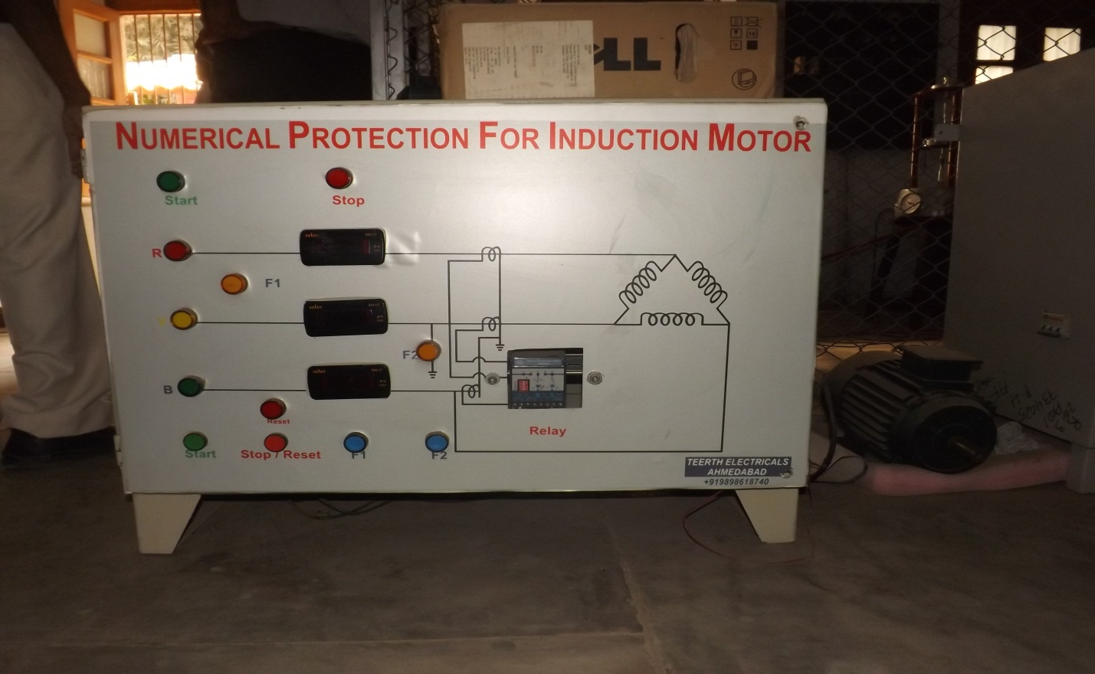

***EQUIPMENT REQUIRED:***

* Three phase induction motor
* CTs
* Numerical relay

**Circuit Diagram**

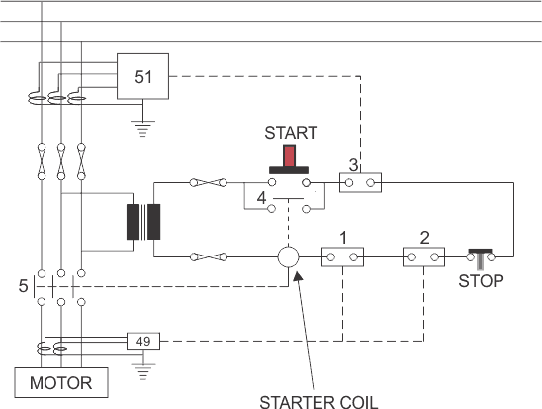

***THEORY:***

The three phase induction motors are very reliable and robust, modern designs operate much closer to the limits of thermal margins and to give adequate protection, sophisticated protective relays are required. In addition, increased industrial use of power electronics leads to incorporate different harmonics in the system, which adversely affect the induction motor performance and cause considerable rotor heating.

The numerical relay has been designed to protect the motor against these phenomena as well as known abuses such as mechanical overload , stalling and locked rotor, short circuit , earth fault , phase unbalancing , single phasing , terminal box and cabling failures , and too frequent starts .

The term single phasing means one of the phase is open. Tis condition subjects the motor to the worst case of voltage unbalance. The phase current will increase by √3 times. Noting can prevent or eliminate single phasing.

A numerical relay is a solid state relay also called static relay. It contains electronic circuitry which may include transistors, ICs, diode and other electronic components. There is a comparator circuit in it, which comparing 2 or more voltages or currents gives output applied to either a slave relay or a thyristor circuit.

The slave relay is an electromagnetic, semi static relay which closes its contacts. The numerical relay as low burden on CT, PT, fast operation, absence of mechanical inertia and contact trouble,long life and less maintenance. So, they are superior to electromagnetic relay, but they are costly and required more maintenance.

***WORKING AND OBSERVATION:***

There are mainly two types of faults on Induction Motor.

1. **Winding – Winding fault:**

This mainly occurs due to insulation failure of stator winding. This type of fault results in imbalance current between two phases. This imbalance current is then served by numerical relay to cause the trip of supply.

1. **Winding – Earth fault:**

When a winding is earthed due to some reasons like insulation failure, ten voltage drop is very fast but current increases. This is a dangerous situation and this imbalance is sensed by the numeric relay which trips the supply of motor.

***RELAY DETAILS:***

The Motor Protection Relay (MPR30) is a tree phase LT motor protection relay for motor sizes up to 50KW (max. 88A current).It is a low cost solution, offering five major protections for motors widely used in fans, pumps, crushers, mills, compressors, belt conveyers, centrifuges, mixers, ventilators, escalators, motorized valves etc. Major advantage is that it provides E/F coordination in contactor-started motors, thus offering greater security, operator safety and economy. The relay is micro-controller based, highly user friendly and compact with inbuilt CTs. The relay can also be used for protection of larger motors by using external CTs.

**SOME BASICS ABOUT HTML USED FOR SIMULATION**

Hypertext Markup Language (HTML) is the standard [markup language](https://en.wikipedia.org/wiki/Markup_language) for creating [web pages](https://en.wikipedia.org/wiki/Web_page) and [web applications](https://en.wikipedia.org/wiki/Web_application). With [Cascading Style Sheets](https://en.wikipedia.org/wiki/Cascading_Style_Sheets) (CSS) and [JavaScript](https://en.wikipedia.org/wiki/JavaScript) it forms a triad of cornerstone technologies for the [World Wide Web](https://en.wikipedia.org/wiki/World_Wide_Web). [Web browsers](https://en.wikipedia.org/wiki/Web_browser) receive HTML documents from a [web server](https://en.wikipedia.org/wiki/Webserver) or from local storage and render them into multimedia web pages. HTML describes the structure of a web page [semantically](https://en.wikipedia.org/wiki/Semantic) and originally included cues for the appearance of the document.

[HTML elements](https://en.wikipedia.org/wiki/HTML_element) are the building blocks of HTML pages. With HTML constructs, [images](https://en.wikipedia.org/wiki/Img_(HTML_element)) and other objects, such as interactive may be embedded into the rendered page. It provides a means to create [structured documents](https://en.wikipedia.org/wiki/Structured_document) by denoting structural [semantics](https://en.wikipedia.org/wiki/Semantics) for text such as headings, paragraphs, lists, [links](https://en.wikipedia.org/wiki/Hyperlink), quotes and other items. HTML elements are delineated by *tags*, written using [angle brackets](https://en.wikipedia.org/wiki/Bracket#Angle_brackets). Tags such as <img /> and <input /> introduce content into the page directly. Others such as <p>...</p> surround and provide information about document text and may include other tags as sub-elements. Browsers do not display the HTML tags, but use them to interpret the content of the page.

HTML can embed programs written in a [scripting language](https://en.wikipedia.org/wiki/Scripting_language) such as [JavaScript](https://en.wikipedia.org/wiki/JavaScript) which affect the behavior and content of web pages. Inclusion of CSS defines the look and layout of content. The [World Wide Web Consortium](https://en.wikipedia.org/wiki/World_Wide_Web_Consortium) (W3C), maintainer of both the HTML and the CSS standards, has encouraged the use of CSS over explicit presentational HTML since 1997.

**IMAGES USED FOR SIMULATION OF EXPERIMENTS**

1. Differential Protection of Transformer
2. Image at initial condition

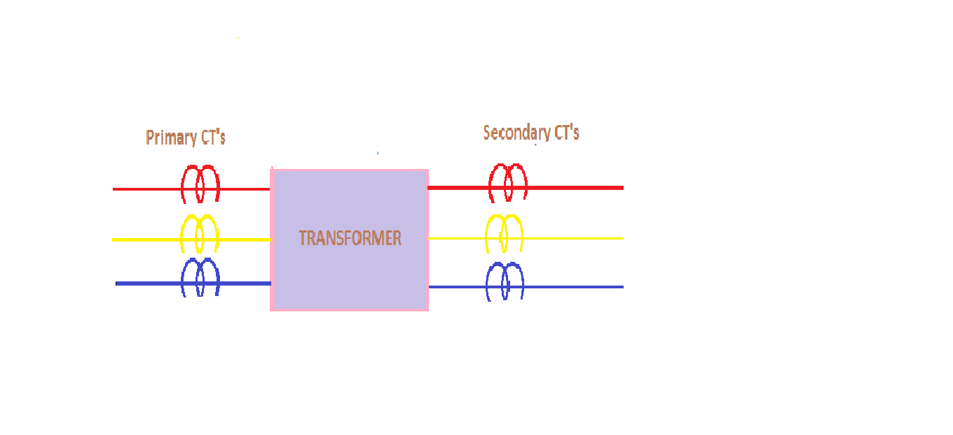

The above image shows the initial condition where the CT terminals are connected as per transformer connection. There is no protection device that is connected to the CT`s.

The protection device in our case is a differential relay.

1. When transformer connection is star-star, then corresponding CTs connection are shown in the image:-

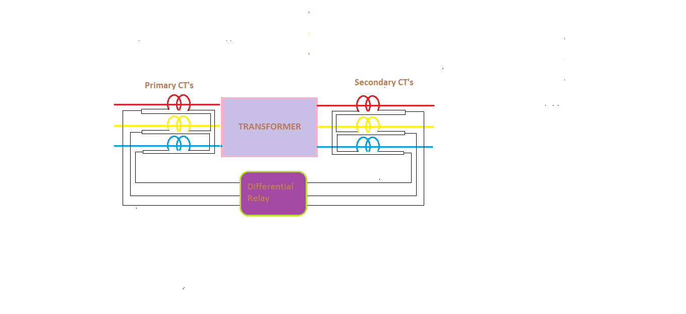

When transformer is star-star connected then CTs connection are reversed i.e. delta-delta and then differential relay connected across CTs connection. When the fault occurs in protected zone i.e. within CTs then switches are opened by differential relay signal.

c) When transformer connection is star-delta, then corresponding CTs connection are shown in the image:-

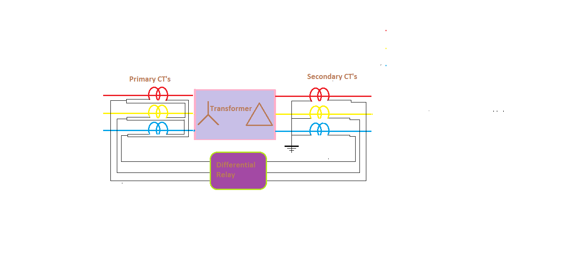 When transformer is star-delta connected then CTs connection are reversed i.e. delta-star and then differential relay connected across CTs connection. When the fault occurs in protected zone i.e. within CTs then switches are opened by differential relay signal.

d) When transformer connection is delta-star, then corresponding CTs connection are shown in the image:-

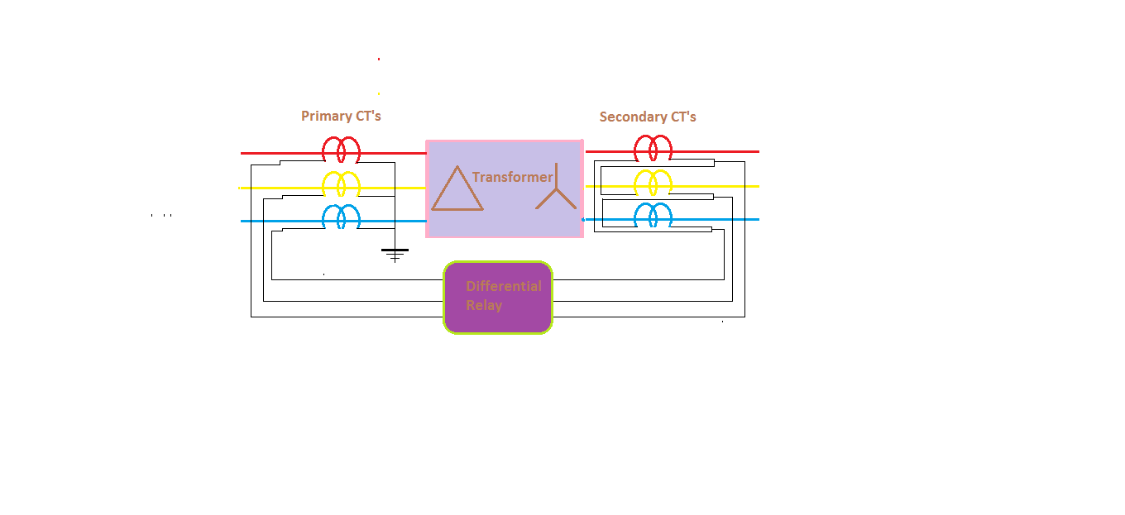

When transformer is delta-star connected then CTs connection are reversed i.e. star-delta and then differential relay connected across CTs connection. When the fault occurs in protected zone i.e. within CTs then switches are opened by differential relay signal.

d) When transformer connection is delta-star, then corresponding CTs connection are shown in the image:-

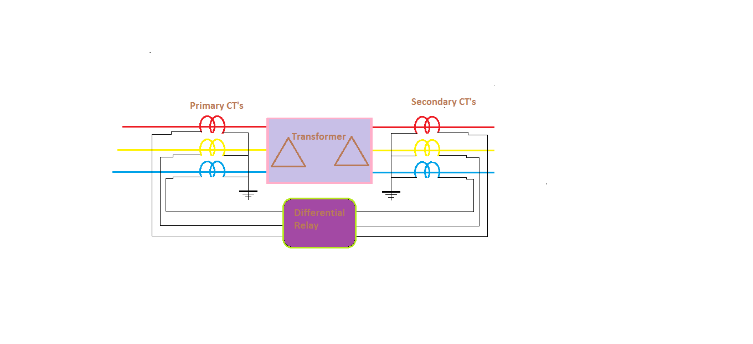

When transformer is delta-star connected then CTs connection are reversed i.e. star-delta and then differential relay connected across CTs connection. When the fault occurs in protected zone i.e. within CTs then switches are opened by differential relay signal.

2. NUMERICALRELAY PROTECTION FOR INDUCTION MOTOR

a) Flow chart for working of numerical relay:-

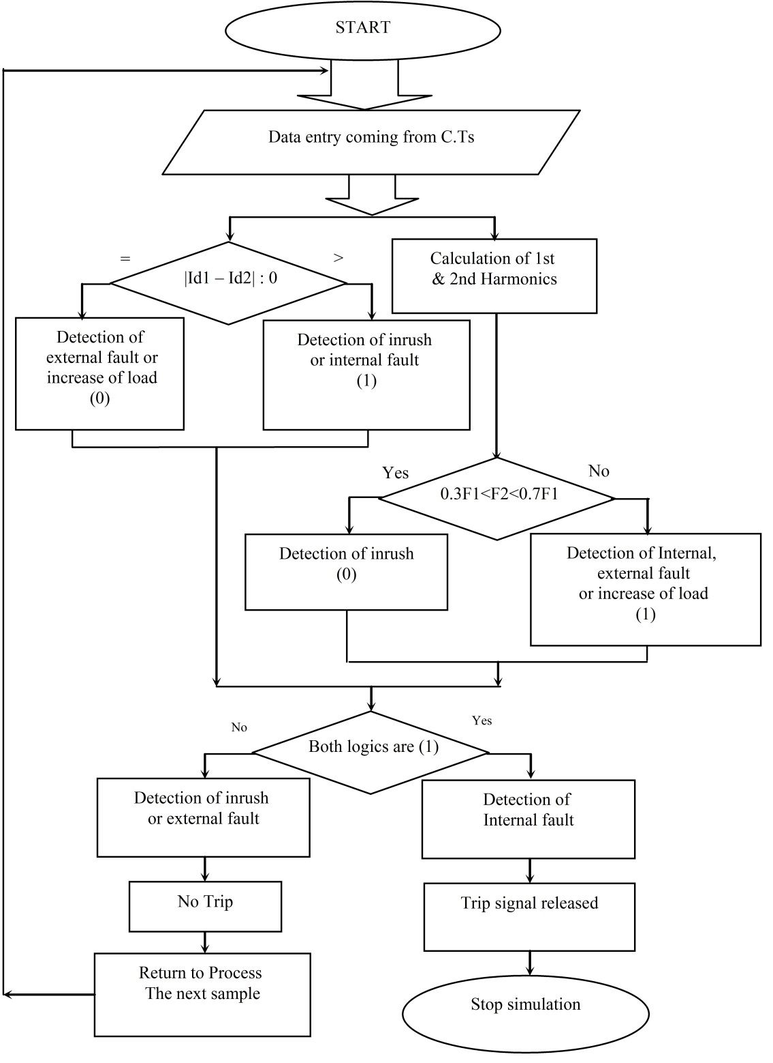

**b)** Figure for simulation of Numerical Relay Protection for Induction Motor

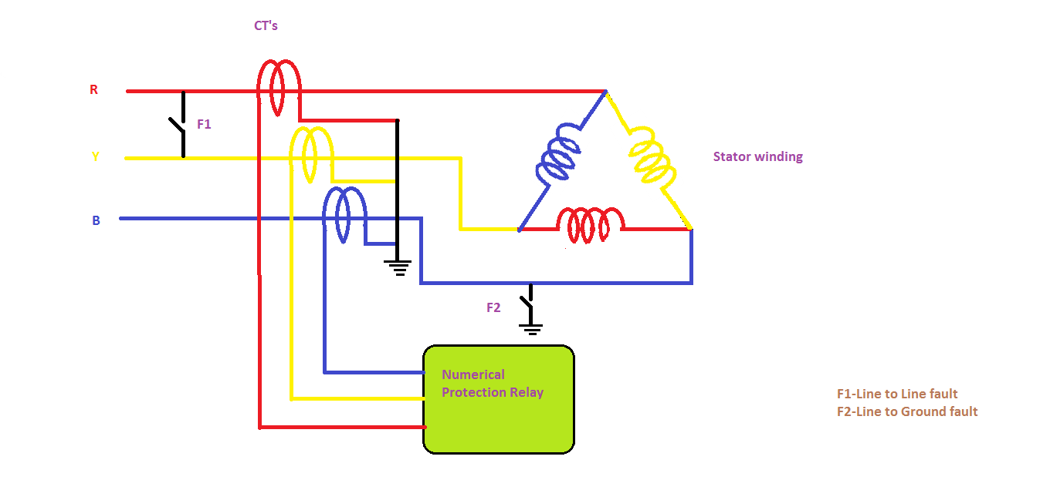

For different type of faults in stator winding of Induction Motor.

Following are the different type of faults in stator winding of Induction Motor:-

a) Line-Line fault:-

In the above image the L-L fault is denoted by F1. When the fault F1 occurs, high current flows through the line where fault occurs. Due to this the value of current flowing through the 3 phases are different.

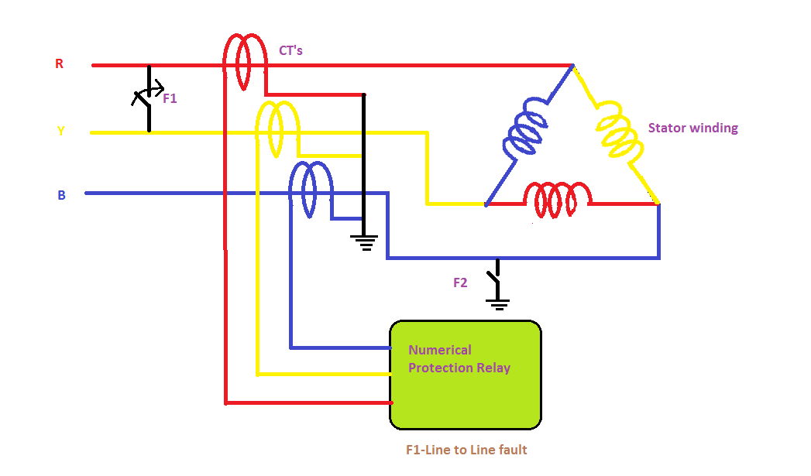

The difference in the value of current in the Y phase and B phase CTs will reach the numerical relay and that difference detected by the relay; hence it gives a signal to the trip circuit to disconnect the supply from the mains.

b) Line – Ground fault:-

In the above image the L-G fault is denoted by F2. When the fault F2 occurs, high current flows through the line where fault occurs i.e., B phase. Due to this the value of current flowing through the 3 phases are different.

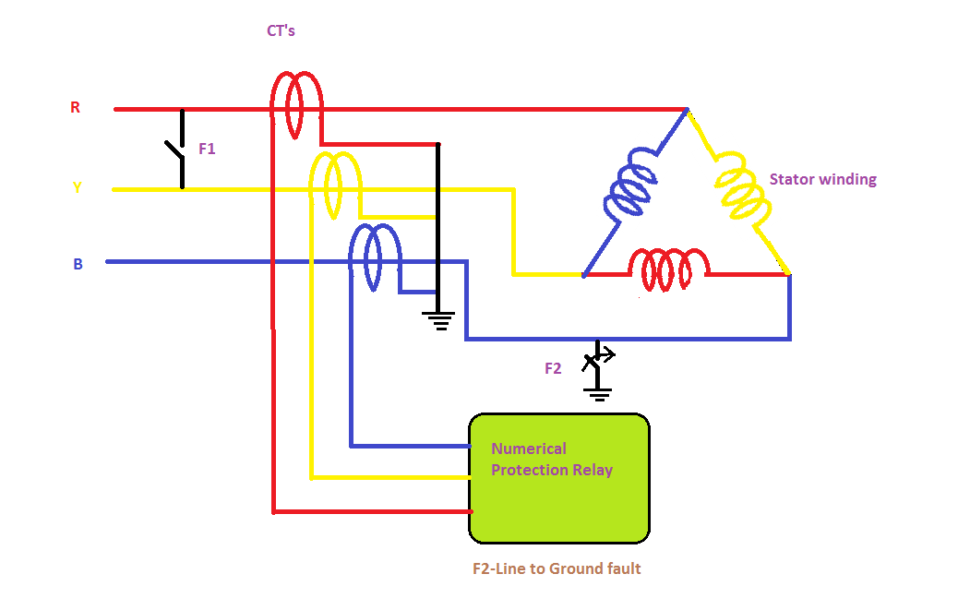

The difference in the value of current in the R phase and B phase CTs will reach the numerical relay and that difference detected by the relay; hence it gives a signal to the trip circuit to disconnect the supply from the mains.

**Reference**

For our project we referred to the following:-

1. DEI Virtual Power Lab website ([www.vlab.dei.co.in](http://www.vlab.dei.co.in))

2. Wikipedia

3. Power Systems by C.L.Wadhwa